Due to charts on Worksheet 1 we can analyze key performance indicators of every given restaurant. On Revenue Trends graph we see that till the middle of February revenue of all restaurants was approximately similar and had similar dynamic. But after that moment revenues had gone in different directions.

Another interesting observation we are doing due to heat diagram “Avg Revenue vs Order Count By Day of Week”: 2 from 3 restaurants have the highest revenues at Sundays and Saturdays. But Lower Manhattan restaurant does not follow this regularity. Restaurant management have to undertake some action to correct this situation.

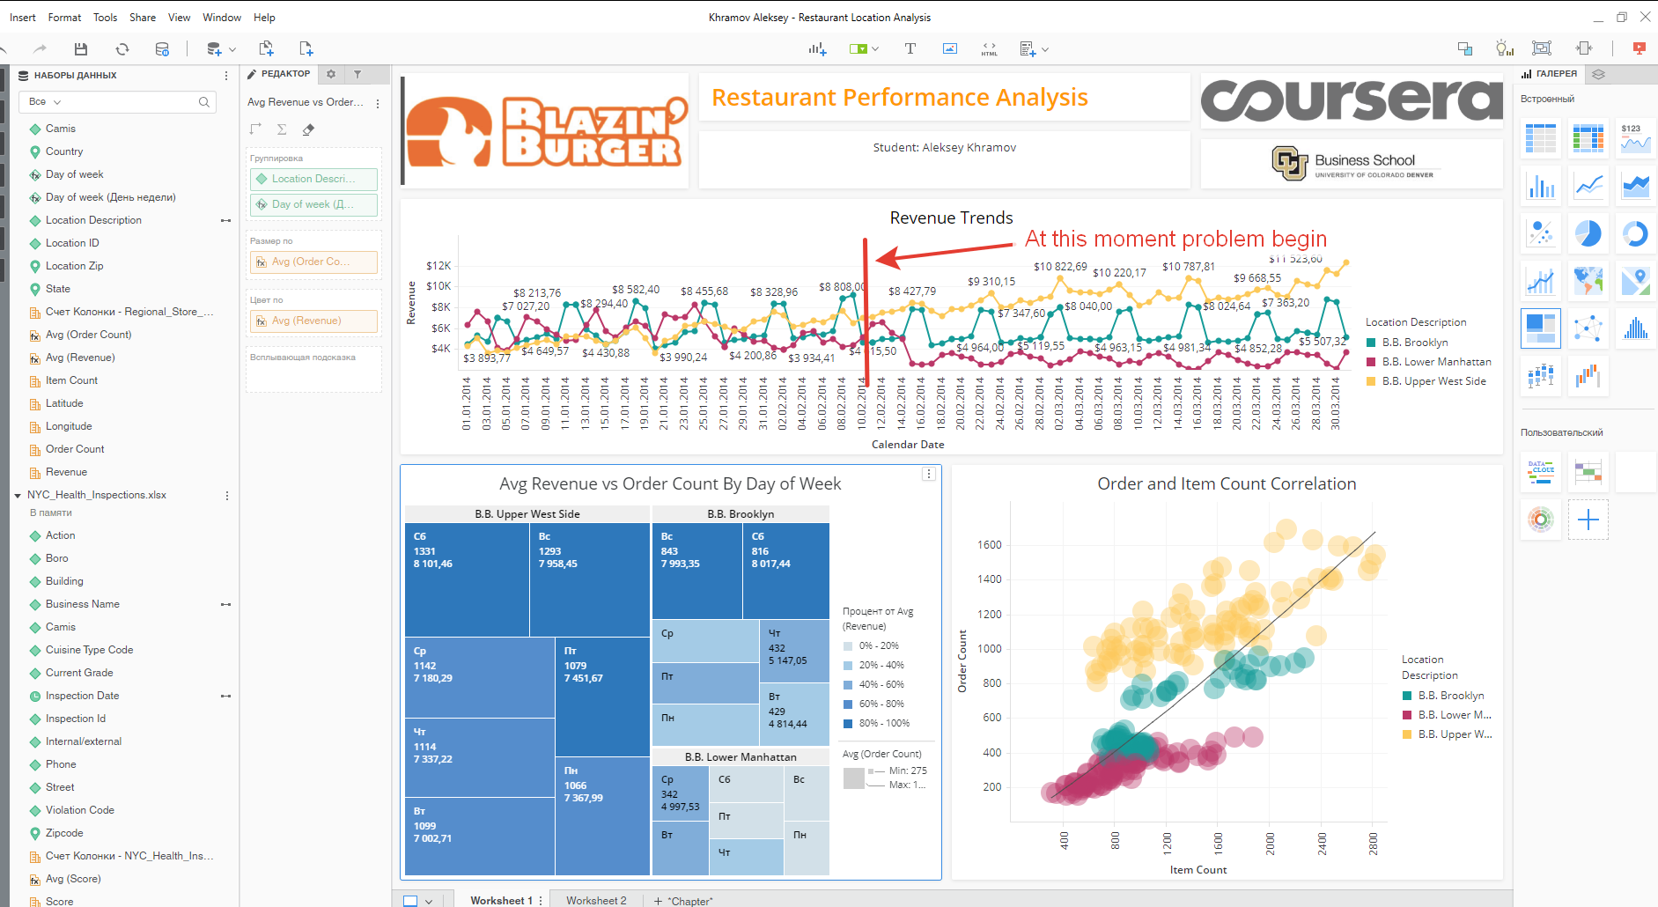

The reason of this problem comes from Worksheet 2 where we analyzing dependency between health inspection results and restaurants revenues. As we see from «Revenue Performance vs Avg Health Score» graph revenues strongly correlate with health score: the higher score – the lower revenue. This fact says that bad financial results of Lower Manhattan and Brooklyn restaurants are caused by inappropriate sanitary situation. Solution: health situation at problem restaurants must be improved.

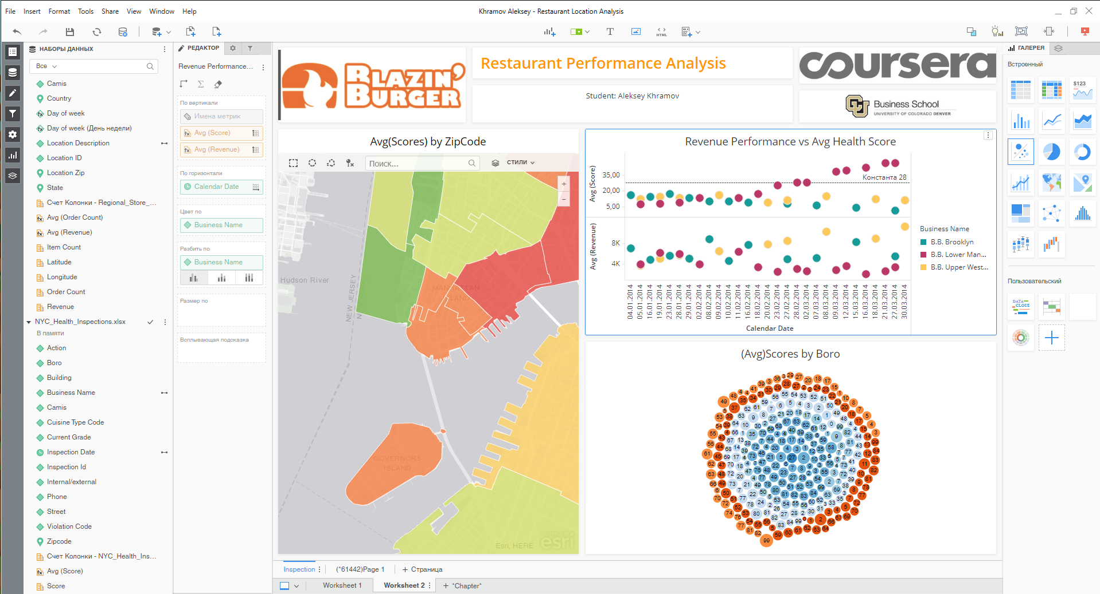

More than have been done already we can additionally add contextual link from «revenue performance vs avg health» to “Avg(Scores) by ZipCode” to highlight particular restaurant district at map and get more data for analyze.